Bushra Hashmi

India and Pakistan won their independence from Britain in August 1947, but the part of Kashmir region was remained disputed between India and Pakistan, both countries declared themselves as nuclear power and conflict of Kashmir remains to undergo.

Cultural Diplomacy in Conflict Zone (Pakistan-India: Chapter)

Januray, 15 2020

**TABLE OF CONTENTS**

Contents

1. Introduction: 2

1.1 Historical Context: 2

1.2 What’s so special about Kashmir? 3

1.3 Pakistan and India War: 3

• **War of 1947- 48:** 4

• **War of 1965:** 4

• **War of 1971:** 4

• **War of 1999:** 5

2. Problem Statement: 5

3. Structure of a Case Study in CD Analysis: 5

• Example CD Case 01: 6

• Example CD Case 02: 6

• Example CD Case 03: 7

• Example CD Case 04: 8

• Example CD Case 05: 9

4. Conclusion: 9

5. Suggestions: 10

6. Closing Note: 10

1. **Introduction:**

Since the existence of civilization, individuals have been practicing and involved in creating relationships or alliances with each other. Different tribes, clans, communities and even in war-like situations, people have kept their ties with one another. In the earliest time of development; Messengers, diplomatic/political agents, Kings/queens were first of their kind who conducted these jobs effectively for their states. [[1]]

Cultural diplomacy has long existed as a tool for international affairs. However, only recently have academics initiated to evaluate its nature and impact. As compared to the 'hard power' of military might, the 'soft power' of cultural diplomacy has often been deeper, lasting, and persuasive. In the India—Pakistan context, achieving peace through cultural diplomacy has great potential. India and Pakistan are connected through a shared history and culture, and despite the seven decades of hostility, several joint initiatives have proven the strength of these connections. [[2]]

## Historical Context:

In Greater India England was ruling since last 200 years, after the end of world war II, England wins the war but economically become weak to control the Indian subcontinent area, the British categorically decided to call-off the long rule in the Indian subcontinent by dividing into two separate nations, Muslim-majority Pakistan and Hindu-majority India. The process of partition, was not simple, thousands of people died and become homeless, it was a difficult time, new war has been started between the Hindus and Muslim, those Muslims wanted to leave the Indian new territory either is being harmed or some of them has been killed because of the hatred among the Muslims and Hindus, which reflect the two-nation theory(Quaid-e-Azam). The subcontinent area was also comprised of various other territories including French, Portuguese or Omani rule, additionally, more than 500 sovereign princely states which governed by local monarchs.

At the time of independence, the British gave the princely states the proposal to join India or Pakistan by signing the Instrument of Agreement with each of the territories and offer them to join or to remain independent. Some princely states did not become part of India or Pakistan until recently. [[3]]

Under the partition plan provided by the Indian Independence Act, Kashmir was free to decide either to join India or Pakistan. The state of Jammu and Kashmir, which had a large Muslim population but ruled by a Hindu leader, Kashmir shared borders with both India and West Pakistan. The maharaja (local ruler), Hari Singh, initially wanted Kashmir to become independent, but in October 1947 due to Indian government religious pressure chose to join India, which eventually not accepted by the public and tension started between the Kashmir Hindus and Muslims.

After more than 70 years Kashmir region remains the only region of British India that has been divided into two parts India and Pakistan and boarder (Line of control) is still not unrecognizable. [[4]]

## What’s so special about Kashmir?

Kashmir is an ethnologically diverse Himalayan region, with the population of 12 Million people (Hindus and Muslims both) covering around 86,000 sq miles (138 sq km), which is estimated size of UK and covered with beautiful lakes and snow-capped mountains, people called as “Switzerland of East”, Pak-India has face-off along a 460-mile (740-kilometer) de facto border known as the **Line of Control**, one of the world’s most armed zones. The region also includes two areas that are controlled by [China](https://www.bloomberg.com/quote/PRCH:CH) and claimed by India(Figure 1).[[5]]

**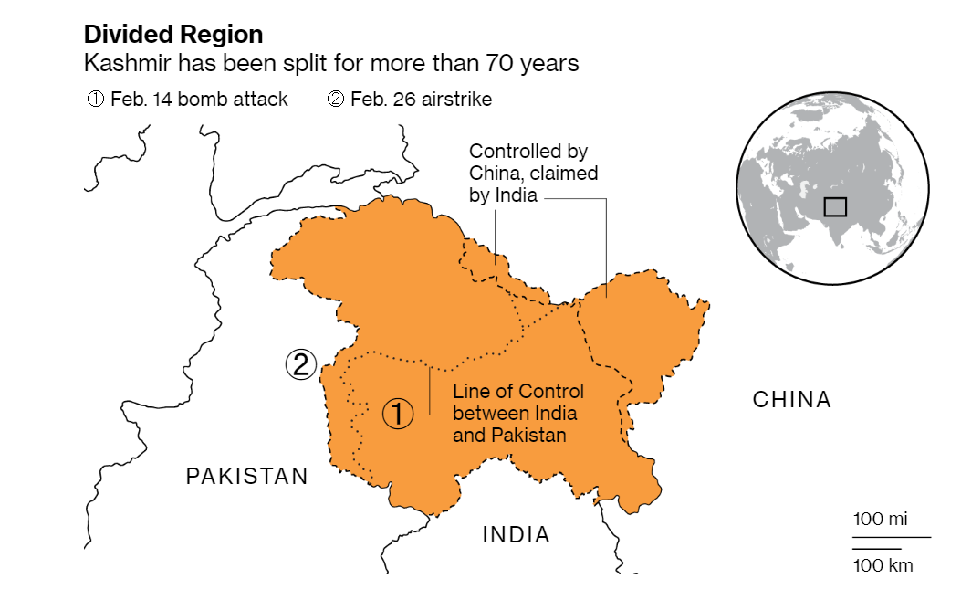  
*Figure 1:*** *Line of control and Divide Region of Kashmir (Source: www.Bloomberg.com)*

## 1.3 Pakistan and India War:

Kashmir is a crucial topic for both the countries, both countries fought four wars in 1947–1948, 1965, 1971 and 1999 and hundreds of small skirmishes at Line of control. the problem has become great political issue for both the countries with no solution in site. There is a serious possibility to visualize another war in near future.

* **War of 1947- 48:**

***Reason:***

The initial war started just after the separation of both the countries on the Kashmir divide in September 1947 when Muslims were killed in the Western part of Kashmir. And people started to rebel against Hindu Maharaja and Muslims Khamis declared their own Azad Kashmir Government. Recognizing it as an opportunity, Pakistan sent their tribal armies near to Kashmir state’s capital, Srinagar. Maharaja asked assistance to India and sign the Instrument of accession to India and accepted the merger of Jammu & Kashmir with India Finally, India sent its forces to Kashmir and**Azad Kashmir movement** was started**.** [**[6]**]

***Effects:***

The War ended because PM Nehru of India pursued the idealistic path of using diplomatic path by involving the United Nations Organisation and force Pakistan to withdraw its irregular forces from J&K. UN try to Peacemaking solution[7]   
Currently, J&k divided into two parts Pakistan Occupied Kashmir (POK) and Indian Occupied Kashmir.

* **War of 1965:**

***Reason:***   
Both the nation also shares many rivers and mountain area, The water of nearly all the rivers – Indus, Chenab, Sutlej, Beas, and Ravi flowed from India, in 1948 a dispute of water started between the countries ,to resolve the issue both the countries signed Indus Water Treaty in 1960 as imposed by United Nations and decided Pakistan used waters of Jhelum, Chenab, and Indus while India used waters of Sutlej, Beas, and Ravi, this contract still hold by both nations.

In 1965, skirmish attacked near Kutch border happened, later Pakistan started sanding para military forces to the Kashmir boarder and penetrated inside India-Occupied Kashmir, India cross the international boarder in Pakistan Lahore city and started Full-Flash War.

***Effects:***

Pakistan **Operation Gibraltar**, which was designed to penetrate forces into Jammu and Kashmir to the insurgency against Indian rule. India reacted by the full-power military attack on West Pakistan, this war goes on seventeen days, resulted in thousands of casualties and dead’s, this war considered as the largest engagement of armored vehicles and tanks after World War II. In 1966 UN Intervene and War ended by signing the subsequent issuance of the**Tashkent Declaration** (to solve all the disputes bilaterally and live in peace). [[8]]

* **War of 1971:**

***Reasons:***

In !970, Pakistan went to the polls in Pakistan Awami National Party of Sheikh Mujeeb-ur-Rehman win the elections, this party was basically Bagnoli oriented and at that moment in center West Pakistan dominated government was ruling, they tried to delay the transfer of power resulting intensive violence’s in Pakistan, India consider it as an opportunity and attack the East and West Pakistan both and win the War.

***Effects:***

With the help of India East-Pakistan has separated and form another country as Bangladesh Shimla Agreement has been signed for the restoration of peace and order between the two states.

**Note:** War of 1971 lasts 13 days and is one of the shortest wars in History- rivaled only by the Six-Day War between the Arab's and the Israelis. [[9]]

* **War of 1999:**

***Reasons:***

The cause of the War was the penetration of Pakistani soldiers and Kashmir militant into **Kargil district**of J & K and along the LOC (Line of Control), Indian army responded with bombing and firing, this war carries forward more than 60 days on Tiger Hill (the highest peak in Kargil Area)

***Effects:***

In February 1999, both states Prime Ministers signed Lahore Declaration, the reason for this declarationto maintain peace and stability in the Kargil area (which is also a disputed land) and between countries for the progress and prosperity of their peoples. [[10]]

1. **Problem Statement:**

*Is the conflict between Pakistan and India based on Kashmir or it is a  
economical and military power game?*

1. **Structure of a Case Study in CD Analysis:**

In both the states negative cultural diplomacy can be observe the restriction or limiting of cultural interactions by the state to protect its national image or interest.goverment fully restricted the business agents to perform any activity with the India and vice versa, moreover Pakistani and Indian TV/Movies artists and singers are also no more allowed to visit the neighboring country for their and same banned also applicable for the TV networks to not to telecast any program or TV channel. In that scenario the only 'power' recognized has been 'hard' power,i.e. military. [[11]]

Besides all the fights, war, distances some cultural diplomacy practices has been observed between both the countries, some of the cases are discussed here;

* **Example CD Case 01:**

|  |  |
| --- | --- |
| Agents | Famous Singers of Pakistan & India |
| Agenda | To make a good relationship between the artists (singers) of Pakistan and India and create Cultural Diplomacy between TV/Film Artists [[12]] |
| Vehicle | * Ghulam Ali a famous Pakistani classic singer sang for a few Bollywood films in the 80s, teaming up with Asha Bhosle (India’s Best Singer). [[13]] * Lata Mangeshkar, Muhammad Rafi the top Indian singers was the most popular singers in Pakistan. * Rahat Fateh Ali Khan who made it to mainstream Bollywood cinema in 2003 with his soulful rendition of Mann ki Lagan in Hindi film Paap. |
| Target Audience | Film/Tv actors, media people and singers of Pakistan and India. |

* **Example CD Case 02:**

|  |  |
| --- | --- |
| Agents | Pakistani & Indian Singers/Music Artist |
| Agenda | CD through International broadcasting, to realize the public of both the nations that we have similar language, tradition and culture.  gaining the attention of the outside world that how rich it is in their culture and how strongly they want to preserve it. |
| Vehicle | * Asia Singing Superstar, broadcast on Pakistani channel GEO TV from, 31 October 2015 – 30 January 2016, judge by Shafqat Amanat Ali, Shankar Mahadevan, Ghulam Ali, Suresh Wadkar(Pakistan & Indian Singers), it was the first show in which the participants were from UAE[[14]] * Sur Kshetra is a 2012 singing talent show or musical battle between teams of two neighboring countries: Pakistan (Atif Aslam) and India (Himmesh Rashmiya), judge by Abida Parveen, Asha Bhosle and Runa Laila. [[15]] |
| Target Audience | Target Audience general public of India and Pakistan. |

* **Example CD Case 03:**

|  |  |
| --- | --- |
| Agents | Pakistani Television Dramas TV Actors |
| Agenda | Public Diplomacy, create Cultural Diplomacy by Pakistani Top TV drama artist visits India and work in Indian Film Industry |
| Vehicle | Mahira Khan and Fawad Khan Top TV artists of the Pakistan industry choose to work with the Indian film industry, not with Pakistan Film Industry.  The list included Imran Abbas, Adnan Siddiqui, Mawra Hocane and many others. |
| Target Audience | Target Audience to attract the general public of India and Pakistan. |

**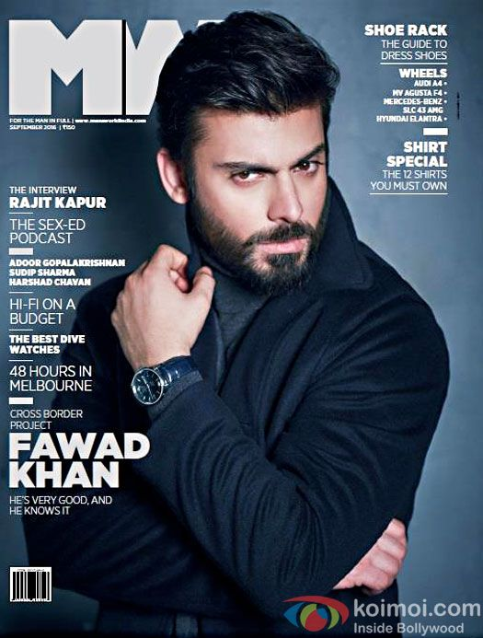*****Figure 2****: Illustrate the Pakistani artist on Indian Magazines Cover (Source:* [*www.GooglePhotos.com*](http://www.GooglePhotos.com)*)*

* **Example CD Case 04:**

|  |  |
| --- | --- |
| Agents | Cricket Team Players |
| Agenda | Cricket Diplomacy The only form of diplomacy seen between the two countries in cricket is the famous sports in both the nations, to organize a match in which both the countries and teams can participate. |
| Vehicle | * The first test series was played in 1951-52 when the Pakistani team went to India, it was the CD practices take place and in return in 1954-55 Indian team visited Pakistan to play cricket. * *no match was played on the home grounds of both India and Pakistan due to the 1965 and 1971 wars between the two countries*. [[16]] |
| Target Audience | Cricket Teams, Sportsperson, the general public of India and Pakistan. |

* **Example CD Case 05:**

|  |  |
| --- | --- |
| Agents | Government Officials of Pakistan and India |
| Agenda | A Kartarpur corridor historic corridor to one of Sikhism's holiest shrines should be open and allowing Indian pilgrims rare visa-free access to the site in Pakistan. [[17]] |
| Vehicle | To build a bridge that will allow visitors to cross over the Ravi river, which flows between the international border and the shrine. (Figure 3) |
| Target Audience | To attract the Sikh Community of India and Pakistan. |

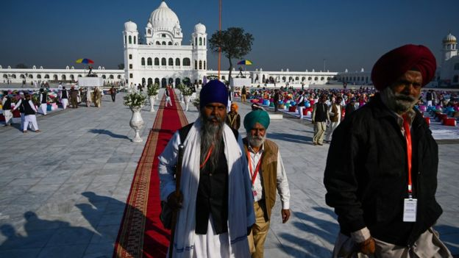

***Figure 3****: Indian pilgrims visit Kartarpur corridor (Source:* [*www.bbc.com*](http://www.bbc.com)*)*

1. **Conclusion:**

* When countries have a similar economic system they mostly are interested in trade, although both the countries are in the war situation, trading relationships have remained the same. Moreover, both the countries have similar crops, similar imports and exports and their trading partners are also same.
* Peace and unity can be gain between economies because of the same culture, values, religion, and language through good governance.
* Both countries can resolve their issues by using their television, films artists and singers and can create peace and Harmony in their relationship.
* Public Diplomacy (government-sponsored programs) practices should be promoted.[18]

In my opinion, the core issue between the two countries is more economical and military power agenda, the Kashmir issue is just created to hide the essential issues and problem.

1. **Suggestions:**

According to Fred Iklé [[19]] two elements must normally be present for negotiation to take place: there must be both common interests and issues of conflict. If the countries have doesn't have any common interests there is nothing to negotiate for, Pak-India, both the nations share the same language, culture, ethnic background, norms, behavior, and lifestyle, they have many common grounds to resolve their conflicts.

Although due to the recent incident about Pakistan captured of Indian pilot tension between two countries is at Peak, but both countries public takes different initiatives to ease down the tension, in recent times, by the opening of Kartarpur border is the biggest initiative took by the Pakistani government, some more suggestions are as follow;

* The media can bring the people close and create harmony between the two nations.
* The media of both countries can play an effective role by objectively presenting the news and display the positive side of the people.
* Pakistan and India should start educational ties and offer scholarships for the students and invite the scholars to come and visit each other and do researches on common interests.
* The literature and syllabus books should not promote the hatred side of a neighboring country.
* There should be cultural exchange programs between India and Pakistan. And the artists should be allowed to freely work in each other’s TV programs and films and there should

be no ban on telecasting each other’s programs in both countries.

* Both the countries should develop the Cultural Center’s in the major cities of other countries.
* Easy visa issuance for travels, for transit students, business as well as on humanitarian grounds.

1. **Closing Note:**

The tools of Cultural Diplomacy can only be implemented, when the state should directly be involved with the cultural diplomacy practices and relax the impact of negative cultural diplomacy.

1. Nimra Javed (2018)
2. Yaqoob K Bangash & Salima Hashmi (2018)
3. Asrar, Shakeeb. "How India, Pakistan, and Bangladesh Were Formed." AlJazeera, 14 Aug. 2019.
4. "Kashmir: Why India and Pakistan fight over It." BBC News, 8 Aug. 2019.
5. Marlow, Lain. “Why India and Pakistan Keep on Clashing.” Bloomberg, 5 Aug. 2019.
6. Shikha Goyal (2019)
7. Charter of the United Nations (1992)
8. Geller, Daniel S. “The India–Pakistan Rivalry: Prospects for War, Prospects for Peace.” The India-Pakistan Conflict, 2005, pp. 80–102.
9. Dixit, J. N. India-Pakistan in War & Peace. Routledge, 2002.
10. Muhammad I Mohmand (2012)
11. Yaqoob K Bangash & Salima Hashmi (2018)
12. Alam, I. (2006). Media and Peace in South Asia. Pakistan: Free Media Foundation.
13. Muhammad I Mohmand (2012)
14. Zeetvusa (2015) <http://www.zeetvusa.com/zeetv/shows/asias-singing-superstar/>
15. “Grand Showdown at Sur Kshetra Finale in Dubai.” Gulf News, 22 Dec. 2012.
16. Holm, 2008
17. “Kartarpur Corridor: India Pilgrims in Historic Visit to Pakistan Temple.” BBC News, 9 Nov. 2019.
18. U.S. Department of State, *Dictionary of International Relations Terms*, [Washington, D.C.], 1987).
19. Fred Iklé (*How Nations Negotiate*,1964)